✅INGREDIENTS TO VACCINES - You CANNOT make an educated decision without being educated.
Here are just SOME vaccine ingredients.
These are being INJECTED into your kids;
◾️Formaldehyde/Formalin - Highly toxic systematic poison and carcinogen.
◾️Betapropiolactone - Toxic chemical and carcinogen. May cause death/permanant injury after very short exposure to small quantities. Corrosive chemical.
◾️Hexadecyltrimethylammonium bromide - May cause damage to the liver, cardiovascular system, and central nervous system. May cause reproductive effects and birth defects.
◾️Aluminum hydroxide, aluminum phosphate, and aluminum salts - Neurotoxin. Carries risk for long term brain inflammation/swelling, neurological disorders, autoimmune disease, Alzheimer's, dementia, and autism. It penetrates the brain where it persists indefinitely.
◾️Thimerosal (mercury) - Neurotoxin. Induces cellular damage, reduces oxidation-reduction activity, cellular degeneration, and cell death. Linked to neurological disorders, Alzheimer's, dementia, and autism.
◾️Polysorbate 80 & 20 - Trespasses the Blood-Brain Barrier and carries with it aluminum, thimerosal, and viruses; allowing it to enter the brain.
◾️Glutaraldehyde - Toxic chemical used as a disinfectant for heat sensitive medical equipment.
◾️Fetal Bovine Serum - Harvested from bovine (cow) fetuses taken from pregnant cows before slaughter.
◾️Human Diploid Fibroblast Cells - aborted fetal cells. Foreign DNA has the ability to interact with our own.
◾️African Green Monkey Kidney Cells - Can carry the SV-40 cancer-causing virus that has already tainted about 30 million Americans. (Rare brain and bone cancers have simian virus surfaced several years ago.)
◾️Acetone - Can cause kidney, liver, and nerve damage.
◾️E.Coli - Yes, you read that right.
◾️DNA from porcine (pig) Circovirus type-1
◾️Human embryonic lung cell cultures (from aborted fetuses)
✳️You can view all of these ingredients on the CDCs website. I encourage everyone to do their own research. Look up the MSDS on these chemicals. Read the thousands of peer reviewed studies that have evaluated the biological consequences these chemicals can have on the body, especially when being injected.
https://www.sciencemag.org/news/2020/08/new-drool-based-tests-are-replacing-dreaded-coronavirus-na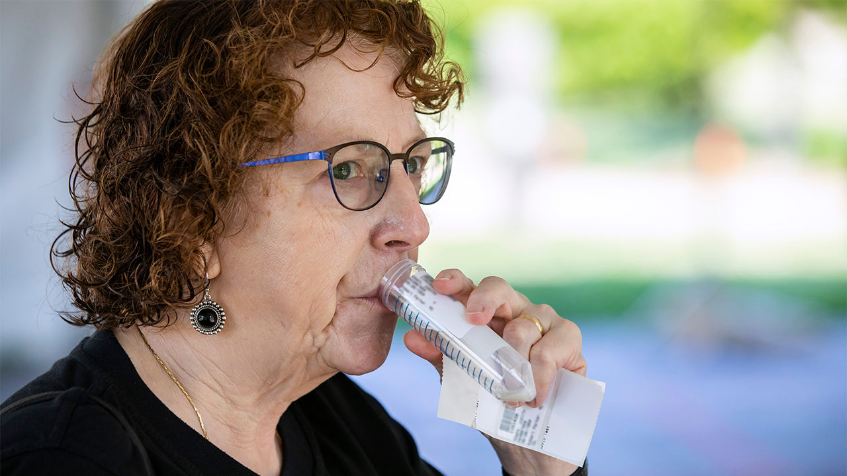sal-swab

https://academic.oup.com/cid/article/71/15/841/5734265

https://www.cdc.gov/vaccines/pubs/pinkbook/downloads/appendices/b/excipient-table-2.pdf
https://www.vaccinesafety.edu/Components-Excipients%2021-0115.pdf ingredients by Moderna and Pfizer not listed

https://search.cdc.gov/search/index.html?query=mouth+swab+tests&sitelimit=coronavirus%2F2019-nCoV&utf8=%E2%9C%93&affiliate=cdc-main
Results returned for mouth swab tests
We are only including results from the COVID-19 site.
Do you want to see results from all sites?
Testing for COVID-19 | CDC
https://www.cdc.gov/coronavirus/2019-ncov/symptoms-testing/testing.html
If you are a close contact of someone with COVID-19 or you are a resident in a community where there is ongoing spread of COVID-19 and develop symptoms of COVID-19, call your healthcare provider and tell them about your symptoms and…
People Also Ask
The US Department of Health and Human Services (HHS) is directly managing allocation of swabs and media, including viral transport medium (VTM), based on state and territory testing plans that were submitted in response to the Coronavirus Aid, Relief, and Economic Security (CARES) Act requirements. Allocations were predetermined to maximize state and territory testing using a data-driven algorithm based on population, high incidence areas, and COVID-19 Task Force’s directives. Currently,
HHS is distributing the following swabs: nasopharyngeal (NP), nasal, foam, and poly swabs.
HHS is distributing the following media: saline, phosphate buffered saline solution (PBS), and VTM.
For specific swab or medium requests, delivery site changes, or other related requests contact COVID19TestSupplies@hhs.gov.

